**Lab 09 Submission Template**

**Name:** Carlos Timoteo

**Student Number:** 040905599

**Completed Topology Diagram (4 marks)**

You need to complete the addressing for the topology shown below.

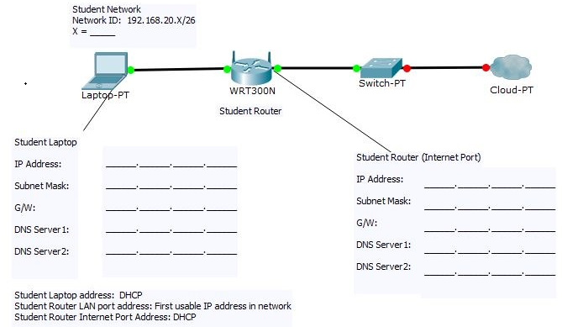

|  |  |  |
| --- | --- | --- |
|  | **Student Laptop** | **Student Router** |
| IP Address | 192.168.20.144 | 172.16.254.55 |
| Subnet Mask | 255.255.255.192 | 255.255.0.0 |
| Gateway | 192.168.20.129 | 172.16.255.254 |
| DNS Server 1 | 192.168.254.254 | 192.168.254.254 |
| DNS Server 2 | 192.168.20.129 | - |

***Screen Captures (4 Marks)***

**Task2-portforward**

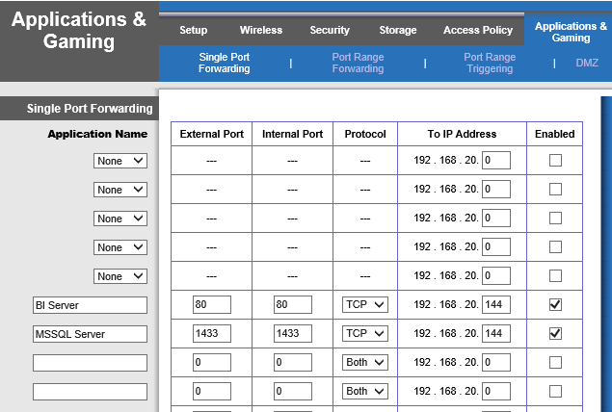

**Task2-netstat**

